Отчет по лабораторной работе №3 (Арифметико-логические устройства)

Задание №1

**Схема одноразрядного АЛУ**

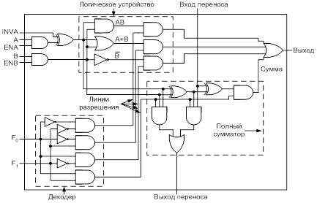

|  |  |  |
| --- | --- | --- |
| F0 | F1 | Функция |
| 0 | 0 | Конъюнкция |
| 0 | 1 | Дизъюнкция |
| 1 | 0 | Инверсия В |
| 1 | 1 | Суммирование |

|  |  |  |
| --- | --- | --- |
| Конъюнкция | | |
| A | B | X0 |
| 0 | 0 | 0 |
| 0 | 1 | 0 |
| 1 | 0 | 0 |
| 1 | 1 | 1 |

|  |  |  |
| --- | --- | --- |
| Дизъюнкция | | |
| А | В | X0 |
| 0 | 0 | 0 |
| 0 | 1 | 1 |
| 1 | 0 | 1 |
| 1 | 1 | 1 |

|  |  |
| --- | --- |
| Инверсия В | |
| B | X0 |
| 0 | 1 |
| 1 | 0 |

|  |  |  |
| --- | --- | --- |
| Суммирование | | |
| A | B | X0 |
| 0 | 0 | 0 |
| 0 | 1 | 1 |
| 1 | 0 | 1 |
| 1 | 1 | 0 |

|  |  |  |  |  |
| --- | --- | --- | --- | --- |
| Суммирование | | | | |
| A | B | INVA | X0 | X1 |
| 0 | 0 | 0 | 0 | 0 |
| 0 | 0 | 1 | 0 | 1 |
| 0 | 1 | 0 | 1 | 0 |
| 0 | 1 | 1 | 1 | 1 |
| 1 | 0 | 0 | 1 | 0 |
| 1 | 0 | 1 | 1 | 0 |
| 1 | 1 | 0 | 0 | 1 |
| 1 | 1 | 1 | 0 | 1 |

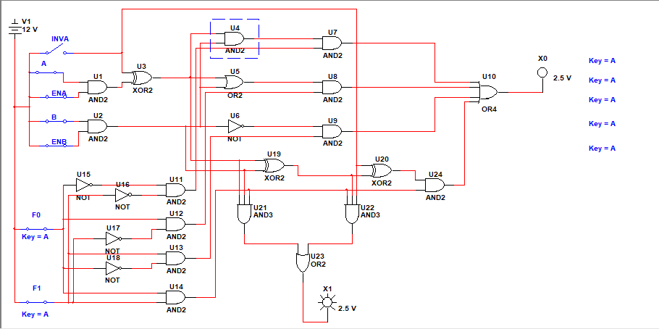

Задание №2

**Схема 4-разрядного АЛУ**

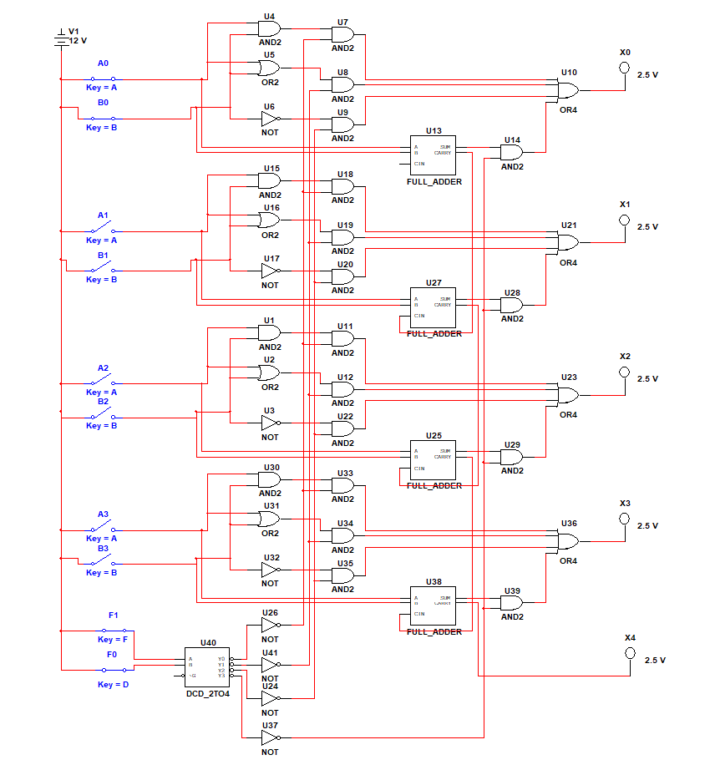

|  |  |  |
| --- | --- | --- |
| F0 | F1 | Функция |
| 0 | 0 | Конъюнкция |
| 0 | 1 | Дизъюнкция |
| 1 | 0 | Инверсия В |
| 1 | 1 | Суммирование |

|  |  |  |  |  |  |  |  |  |  |  |  |  |
| --- | --- | --- | --- | --- | --- | --- | --- | --- | --- | --- | --- | --- |
| Конъюнкция | | | | | | | | | | | | |
| A0 | B0 | A1 | B1 | A2 | B2 | A3 | B3 | X0 | X1 | X2 | X3 | X4 |
| 0 | 0 | 0 | 0 | 0 | 0 | 0 | 1 | 0 | 0 | 0 | 0 | 0 |
| 0 | 0 | 0 | 0 | 0 | 0 | 1 | 0 | 0 | 0 | 0 | 0 | 0 |
| 0 | 0 | 0 | 0 | 1 | 1 | 0 | 0 | 0 | 0 | 1 | 0 | 0 |
| 1 | 1 | 1 | 1 | 1 | 0 | 0 | 0 | 1 | 1 | 0 | 0 | 0 |
| 1 | 1 | 1 | 1 | 1 | 1 | 1 | 1 | 1 | 1 | 1 | 1 | 1 |
| 1 | 0 | 1 | 0 | 1 | 0 | 1 | 0 | 0 | 0 | 0 | 0 | 0 |
| 1 | 1 | 1 | 0 | 0 | 0 | 0 | 0 | 1 | 0 | 0 | 0 | 0 |
| 0 | 1 | 0 | 1 | 0 | 1 | 0 | 1 | 0 | 0 | 0 | 0 | 0 |

|  |  |  |  |  |  |  |  |  |  |  |  |  |
| --- | --- | --- | --- | --- | --- | --- | --- | --- | --- | --- | --- | --- |
| Дизъюнкция | | | | | | | | | | | | |
| A0 | B0 | A1 | B1 | A2 | B2 | A3 | B3 | X0 | X1 | X2 | X3 | X4 |
| 0 | 0 | 0 | 0 | 0 | 0 | 0 | 1 | 0 | 0 | 0 | 1 | 0 |
| 0 | 0 | 0 | 0 | 0 | 0 | 1 | 0 | 0 | 0 | 0 | 1 | 0 |
| 0 | 0 | 0 | 0 | 1 | 1 | 0 | 0 | 0 | 0 | 1 | 0 | 0 |
| 1 | 1 | 1 | 1 | 1 | 0 | 0 | 0 | 1 | 1 | 1 | 0 | 0 |
| 1 | 1 | 1 | 1 | 1 | 1 | 1 | 1 | 1 | 1 | 1 | 1 | 1 |
| 1 | 0 | 1 | 0 | 1 | 0 | 1 | 0 | 1 | 1 | 1 | 1 | 0 |
| 1 | 1 | 1 | 0 | 0 | 0 | 0 | 0 | 1 | 1 | 0 | 0 | 0 |
| 0 | 1 | 0 | 1 | 0 | 1 | 0 | 1 | 1 | 1 | 1 | 1 | 0 |

|  |  |  |  |  |  |  |  |  |  |  |  |  |
| --- | --- | --- | --- | --- | --- | --- | --- | --- | --- | --- | --- | --- |
| Инверсия В | | | | | | | | | | | | |
| A0 | B0 | A1 | B1 | A2 | B2 | A3 | B3 | X0 | X1 | X2 | X3 | X4 |
| 0 | 0 | 0 | 0 | 0 | 0 | 0 | 1 | 1 | 1 | 1 | 0 | 0 |
| 0 | 0 | 0 | 0 | 0 | 0 | 1 | 0 | 1 | 1 | 1 | 1 | 0 |
| 0 | 0 | 0 | 0 | 1 | 1 | 0 | 0 | 1 | 1 | 0 | 1 | 0 |
| 1 | 1 | 1 | 1 | 1 | 0 | 0 | 0 | 0 | 0 | 1 | 1 | 0 |
| 1 | 1 | 1 | 1 | 1 | 1 | 1 | 1 | 0 | 0 | 0 | 0 | 1 |
| 1 | 0 | 1 | 0 | 1 | 0 | 1 | 0 | 1 | 1 | 1 | 1 | 0 |
| 1 | 1 | 1 | 0 | 0 | 0 | 0 | 0 | 0 | 1 | 1 | 1 | 0 |
| 0 | 1 | 0 | 1 | 0 | 1 | 0 | 1 | 0 | 0 | 0 | 0 | 0 |

|  |  |  |  |  |  |  |  |  |  |  |  |  |
| --- | --- | --- | --- | --- | --- | --- | --- | --- | --- | --- | --- | --- |
| Суммирование | | | | | | | | | | | | |
| A0 | B0 | A1 | B1 | A2 | B2 | A3 | B3 | X0 | X1 | X2 | X3 | X4 |
| 0 | 0 | 0 | 0 | 0 | 0 | 0 | 1 | 0 | 0 | 0 | 1 | 0 |
| 0 | 0 | 0 | 0 | 0 | 0 | 1 | 0 | 0 | 0 | 0 | 1 | 0 |
| 0 | 0 | 0 | 0 | 1 | 1 | 0 | 0 | 0 | 0 | 0 | 1 | 0 |
| 1 | 1 | 1 | 1 | 1 | 0 | 0 | 0 | 0 | 1 | 0 | 1 | 0 |
| 1 | 1 | 1 | 1 | 1 | 1 | 1 | 1 | 0 | 1 | 1 | 1 | 1 |
| 1 | 0 | 1 | 0 | 1 | 0 | 1 | 0 | 1 | 1 | 1 | 1 | 0 |
| 1 | 1 | 1 | 0 | 0 | 0 | 0 | 0 | 0 | 0 | 1 | 0 | 0 |
| 0 | 1 | 0 | 1 | 0 | 1 | 0 | 1 | 1 | 1 | 1 | 1 | 0 |

Задание №3

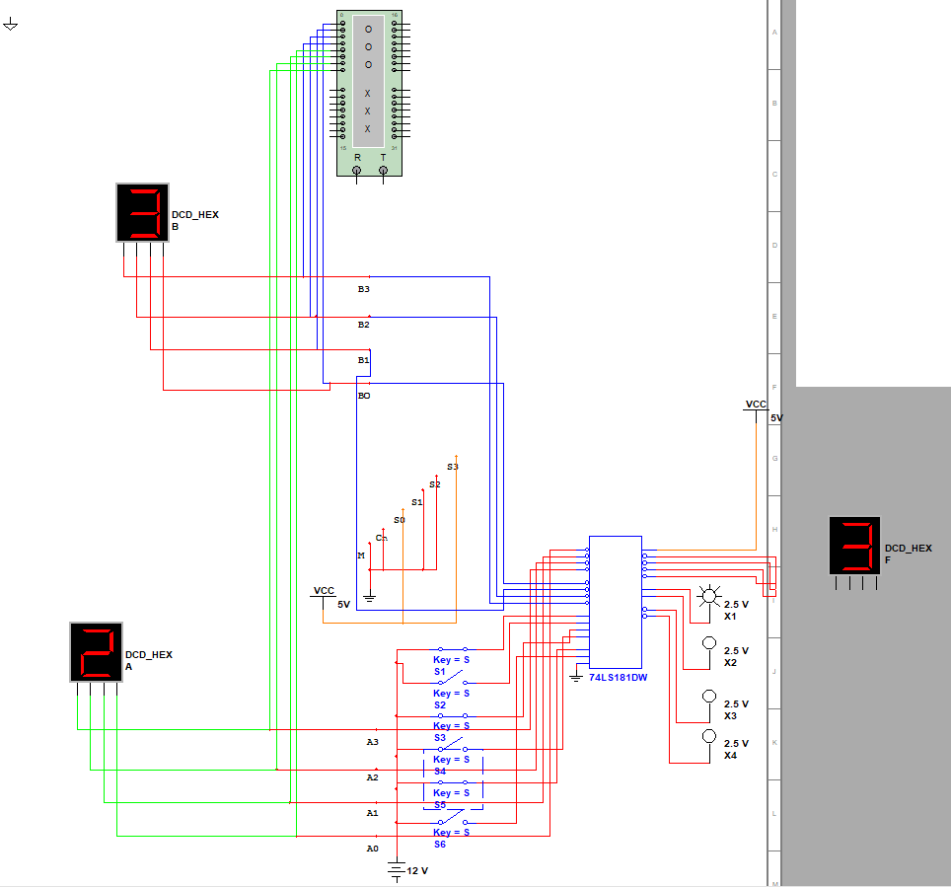

|  |  |  |  |  |  |  |  |  |  |
| --- | --- | --- | --- | --- | --- | --- | --- | --- | --- |
| S1 | S2 | S3 | S4 | S5 | S6 | X1 | X2 | X3 | X4 |
| 0 | 0 | 0 | 0 | 0 | 1 | 1 | 0 | 0 | 0 |
| 0 | 0 | 0 | 0 | 1 | 0 | 1 | 0 | 0 | 0 |
| 0 | 0 | 0 | 0 | 1 | 1 | 1 | 0 | 0 | 0 |
| 0 | 0 | 0 | 1 | 0 | 0 | 1 | 0 | 1 | 0 |
| 0 | 0 | 0 | 1 | 0 | 1 | 1 | 0 | 1 | 0 |
| 0 | 0 | 0 | 1 | 1 | 0 | 1 | 0 | 1 | 0 |
| 0 | 0 | 0 | 1 | 1 | 1 | 1 | 0 | 1 | 0 |
| 0 | 0 | 1 | 0 | 0 | 0 | 1 | 0 | 0 | 0 |
| 0 | 0 | 1 | 0 | 1 | 0 | 1 | 0 | 1 | 0 |
| 0 | 1 | 1 | 1 | 1 | 1 | 0 | 0 | 1 | 1 |
| 1 | 1 | 1 | 1 | 1 | 1 | 0 | 0 | 1 | 1 |
| 0 | 0 | 0 | 0 | 0 | 0 | 1 | 0 | 0 | 0 |
| 1 | 1 | 1 | 0 | 0 | 0 | 0 | 0 | 0 | 1 |
| 0 | 1 | 0 | 1 | 0 | 1 | 0 | 0 | 1 | 1 |
| 1 | 0 | 1 | 0 | 1 | 0 | 1 | 0 | 0 | 0 |

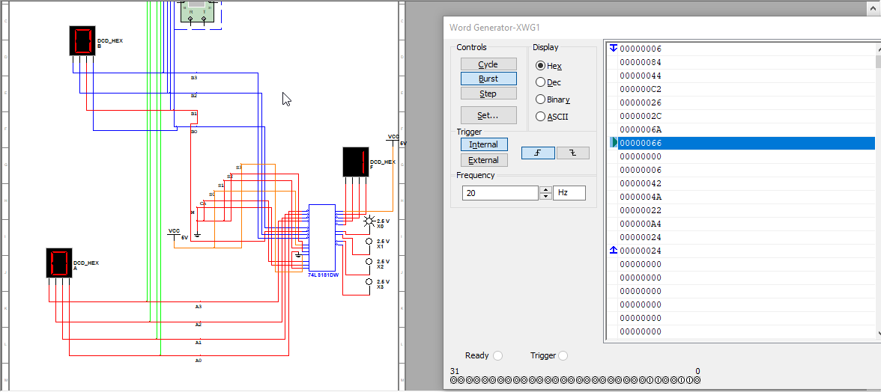

|  |  |  |  |  |  |  |  |
| --- | --- | --- | --- | --- | --- | --- | --- |
| Word Generator-XWG1 (Hex) | A | B | F | X0 | X1 | X2 | X3 |
| 6 | 0 | 6 | 7 | 1 | 0 | 0 | 0 |
| 84 | 4 | 4 | 9 | 1 | 0 | 1 | 0 |
| 44 | C | 2 | F | 1 | 0 | 0 | 0 |
| C2 | 2 | 6 | 9 | 1 | 0 | 1 | 0 |
| 26 | 2 | C | F | 1 | 0 | 0 | 0 |
| 2C | 6 | A | 1 | 0 | 0 | 1 | 1 |
| 6A | 6 | 6 | D | 1 | 0 | 1 | 0 |
| 66 | 0 | 0 | 1 | 1 | 0 | 0 | 0 |
| 0 | 0 | 0 | 0 | 0 | 0 | 0 | 0 |
| 42 | 4 | A | F | 1 | 0 | 0 | 0 |
| 4A | 2 | 2 | 5 | 1 | 0 | 1 | 0 |
| 22 | A | 4 | F | 1 | 0 | 0 | 0 |
| A4 | 2 | 4 | 7 | 1 | 0 | 0 | 0 |
| 24 | 2 | 4 | 7 | 1 | 0 | 0 | 0 |